Experiment: CNN for Image Classification
Aim: To design and implement a Convolutional Neural Network (CNN) for classification of an image dataset using TensorFlow and Keras.
Suggested dataset: Fashion-MNIST – 10 clothing categories
CNN Architecture:
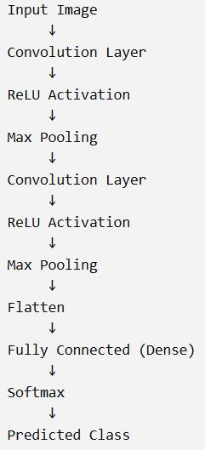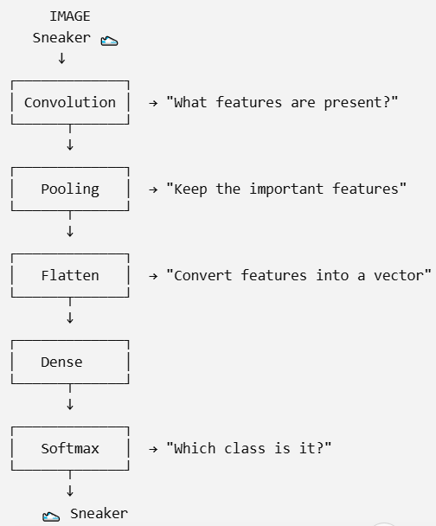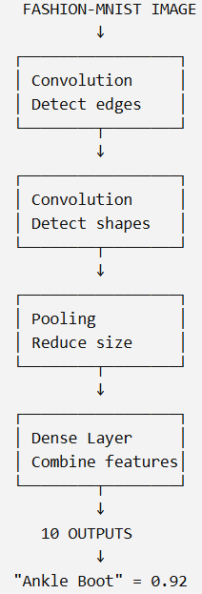
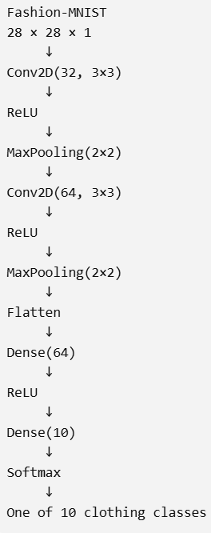
This is the architecture for our fashion MNIST dataset
Find features → Keep important features → Convert them → Decide the class

